Dear Sandyford Business,

The Valuations Office is currently revaluing all retail, commercial and industrial properties in the Dun Laoghaire Rathdown County.

As a result your rates bill may increase significantly next year. Inspections are underway and new valuation certificates are due to issue next month - June 2010. After issuance of the new certificates there are strict timelines open to businesses to act and/or appeal.

SBEA is pleased to advise that our member O'Donnell Property Consultants has put in place both a guide to the process (available to all members) and an affinity scheme (details below) for SBEA MEMBERS who may wish to avail of professional advice in appealing the new valuations.

If you want to learn more, contact us at sbeassoc@eircom.net

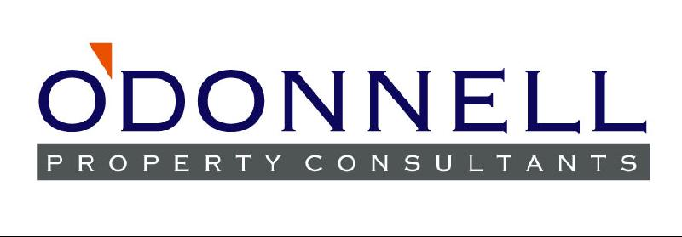
The Revaluation of all commercial property is currently under way in the
Dun Laoghaire-Rathdown County Council area.
Proposed Certificates are due to be issued to all Rate Payers
in June 2010

If you are concerned about your liability for Rates you should contact an experienced Rating Consultant for advice

  O'Donnell Property Consultants
  29 Sandyford Office Park
  Sandyford
  Dublin 18
  Tel: 01 2939094
  Fax: 01 2939095
  Email: info@odonnellproperty.ie
  www.odonnellproperty.ie
  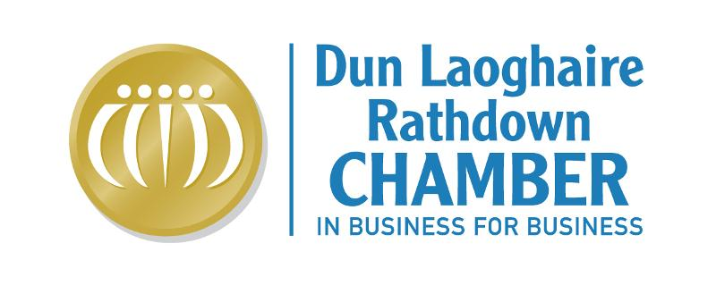
  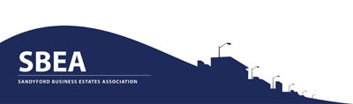
   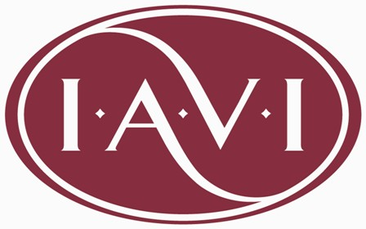
  ISME
  Contact:
  Terry Devlin
  B.Sc., ASCS, MRICS, MIAVI
  Email:
  tdevlin@odonnellproperty.ie
  Tel: 01 2939094
  Martin O'Donnell
  B.A., ASCS, MRICS, FIAVI
  Email:
  modonnell@odonnellproperty.ie
  Tel: 01 2939094
  O'Donnell Property Consultants
  - are specialist Rating Consultants
  - have over 30 years experience in appealing rating assessments
  - are fully qualified Chartered Valuation Surveyors
  - have essential local knowledge as we are based in the Dun Laoghaire Borough
  - are members of Sandyford Business Estates Association and Dun Laoghaire Rathdown Chamber
  - have valuable experience in advising on the first two Revaluations already conducted in South Dublin County Council and Fingal County Council
  - are located in Sandyford and are fellow members of SBEA
  - are proposing no minimum fees and therefore we will only get paid if we save ratepayers money

SBEA AFFINITY SCHEME
SPECIAL FEES
40% of the first year's savings in rates
to
Professionally advise on Rates Assessments under the Dun Laoghaire Rathdown Revaluation
No foal no fee - fees only applicable where savings are achieved
The proposed fee is subject to:
VAT at the relevant rate (currently 21%)
the savings achieved on the assessment in the "proposed valuation certificate"
includes professional work up to and including first appeal with the Commissioner of Valuation. In the event that a further appeal is required to the Valuation Tribunal a further fee will apply by agreement.

This email was sent to lucie@odonnellproperty.ie by modonnell@odonnellproperty.ie.  Update Profile/Email Address | Instant removal with SafeUnsubscribe™ | Privacy Policy. | Email Marketing by  
O'Donnell Property Consultants | 29 Sandyford Office Park | Sandyford | Dublin 18 | Ireland

