M50 Phase 2 Underway

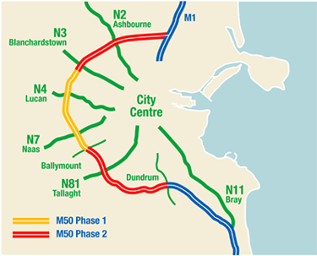
UPGRADING 24KM IN EACH DIRECTION BETWEEN M1 (Airport Interchange) and M11
Phase 2 of the M50 Upgrade Project has started (January 2008), to upgrade the section of motorway
- from the M1 (Airport) Interchange to the N3 (Blanchardstown) Interchange at the northern end and
- between Ballymount and the M11 on the southern end.
The full work zone is 24km in length and will consist of
- a third lane in each direction
- junction upgrades
- an additional fourth lane between adjacent interchanges.

Traffic Management Plan
Impact on traffic during this construction project is unavoidable, but the project team is putting in place a detailed traffic management plan to minimise disruption and ensure that the existing capacity remains not only during rush hours but also right through the day
- Two lanes will be operational in each direction at all times between 6am and 10pm Monday to Saturday and from 8am to 10pm on Sundays.
- A 60km/hr speed limit will apply for the duration of works.
- A 24-hour Emergency Lane will be provided in each direction.
- A 24-hour Emergency Phone Line for motorway users – 1800 77 50 50
- Comprehensive road signage will be in place.
Visit www.m50.ie for regular, up-to-date information on traffic management plans throughout construction.

